Axel Ferdinan Ekstrom, Captain, Co. G, 65th IL Infantry, USA

1824 Oct 22: Axel Ferdinan Ekstrom was born in Sweden.

1846 Axel Ekstrom immigrated to America.

1852 Axel Ekstrom settled in Rock Island, IL.

1860 (abt) married Eliza Ann Arrasmith in Rock Island ,IL.

June 14: The US Federal Census enumerated in Rock Island County, IL listed Axel Ekstrom at thirty four years old employed as a day laborer. Eliza was listed as “wife.”

1862 February 10: Enlisted in 65th IL Infantry as a 1st sergeant, Co. B.

March 15: Mustered into 65th IL Infantry.

November 1: Promoted to 1st Lt and transferred to Co. G.

1863 May 31: Promoted to Captain of Co. G.

1864 November 30: Fought at the Battle of Franklin with the 65th IL Infantry. He was a Captain in command of company G. This regiment was positioned on the main defensive line under Col. John Casement’s brigade command. They faced a Confederate assault consisting of French’s division of Mississippians and Missourians, Walthall’s Division of Tennessee, Alabama, and Arkansas troops and elements of Patrick Cleburne’s feared division. They repulsed these attacks and Axel Ekstrom was wounded in the scalp during this battle.
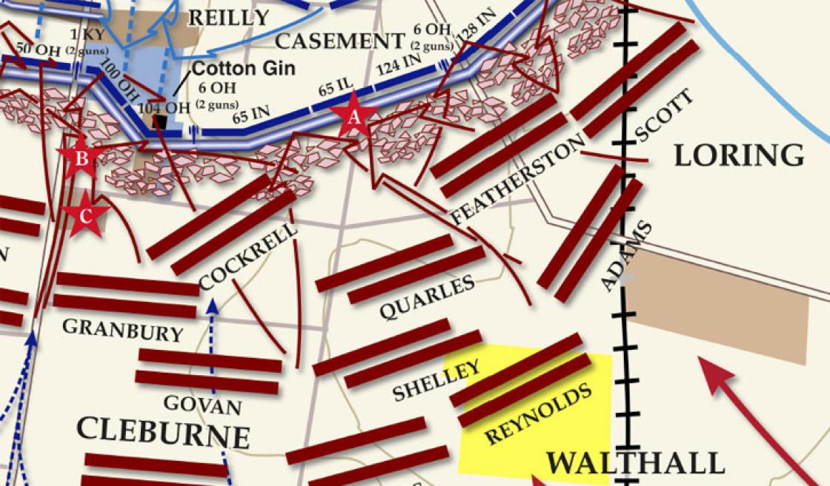

1865 April 25: Mustered out of 65th IL Infantry

1866 January 15: Axel Ekstrom became a naturalized citizen of the United States of America.

1880 June 1: The US Federal Census enumerated in Rock Island, IL listed Axel at fifty six years old employed as a “grain dealer.” His wife Eliza was listed as “keeping house.” They had six children aged seventeen to three years old that lived with them. They also had a nineteen year old servant by the name of Sophia Sloatz that lived with them.

1900 June 2: The US Federal Census enumerated in Rock Island County, IL showed Axel Ekstrom at seventy five years old employed as a grocer. He lived with his wife Eliza and one daughter named Minola. This census states that Eliza bore nine children but only seven survived. The previous household listed was Axel’s son Charles. He was listed at twenty six years old as a grocery clerk. It is likely he worked for his father at his grocery.

1903 Oct 31: Axel Ferdinan Ekstrom died at the age of seventy nine. He was buried in the Andalusia Cemetery in Andalusia, IL.

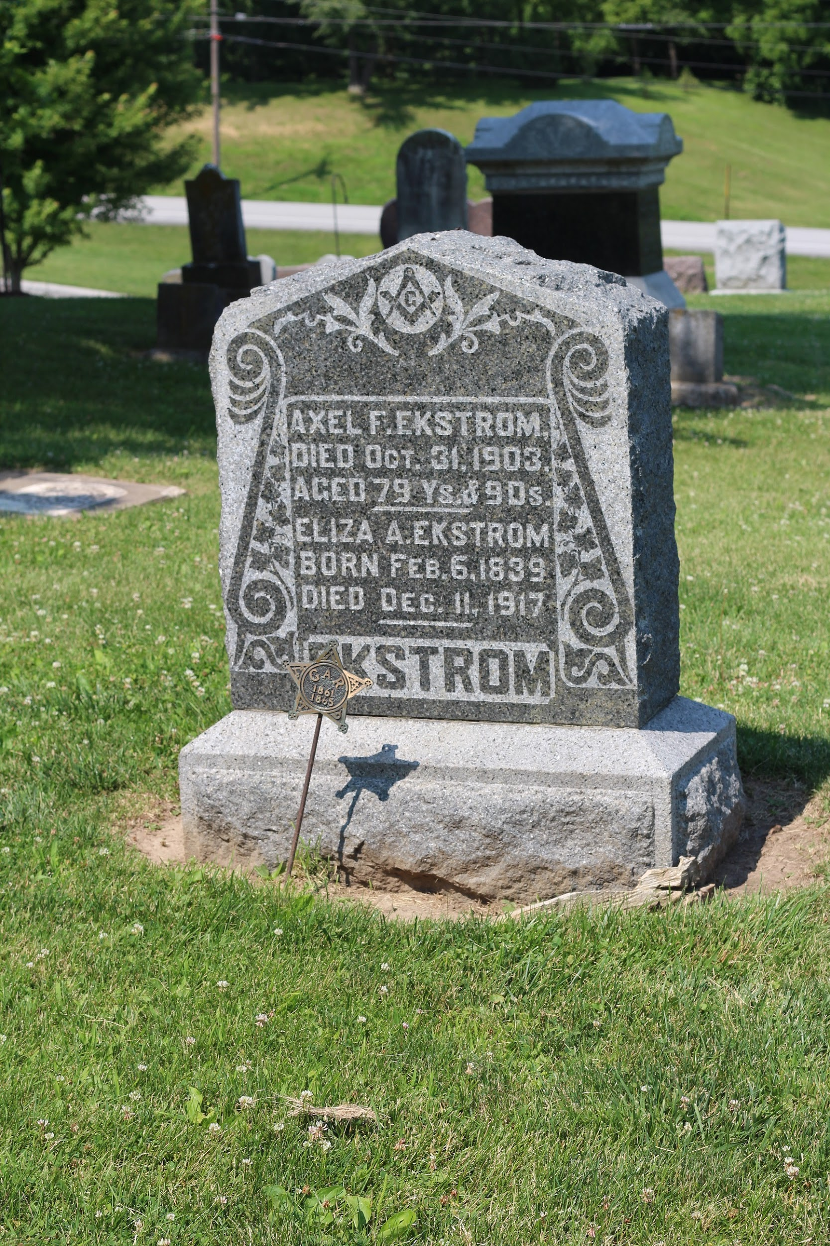

findagrave/user/Emily Jones

