Otho Collier, 1st Sergeant, Co. D, 100th OH Infantry, USA

1827 Otho Collier was born to parents Joseph and Mary Ann Collier in Ohio.

1850 July 20: The US Federal Census enumerated in Defiance County, OH listed Otho Collier as a twenty three year old man living in the household of a Judge named George B Way. Otho was listed as a “wagon maker.”

Nov 21: Married Elizabeth Ann Kepler in Defiance County, OH.

1860 July 11: The US Federal Census enumerated in Defiance County, OH showed thirty three year old Otho Collier resided with his wife, Elizabeth, and their three children. He was employed as a farmer.

1862 July 18: Enlisted as a Corporal in Co. D, 100th OH Infantry

November 28: Promoted to Sergeant, Co. D, 100th OH Infantry

1864 July 29: Promoted to 1st Sergeant, Co. D, 100th OH Infantry

November 30: Otho Collier and the 100th OH Infantry were posted on the main defensive line under Brig. Gen. James Reilly’s brigade command. They were positioned near the Columbia Pike and the gap in the earthworks there allowed Confederate and retreating Federal troops to pour into the lines and caused chaos. Otho Collier was captured by Confederate troops during the battle and sent to Andersonville, GA as a prisoner. He survived this ordeal.

1865 June 14: Mustered out of 100th OH Infantry at Camp Chase, OH.

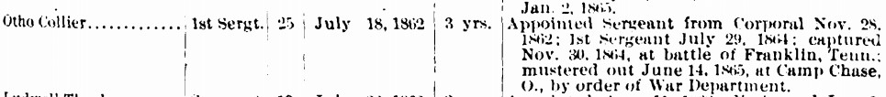

1870 June 23: The US Federal Census enumerated in Defiance County, OH listed Otho Collier at forty three years old. He lived with his wife Elizabeth, four children and was employed as a farmer.

1880 June 28: The US Federal Census enumerated in Defiance County, OH listed Otho Collier at fifty three years old employed as a farmer. He lived with his wife Elizabeth and four children.

1886 Otho Collier was listed as sheriff in Hicksville, OH in 1876.

1898 January 21: Otho Collier died in Wayne County, MI. He was buried at Glenwood Cemetery in Wayne, MI. He was about seventy one years old.

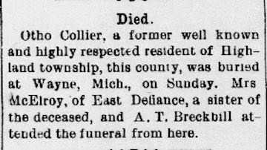

The Hicksville News, Hicksville, OH, Thursday, Oct 28, 1886.

